**Engineering Workflow – Certification Functionality**  
  
**A. Certification Staff (Setting up OMT Members, Unit Members)**  
  
The certification staff screen allows an administrator to specify which employees show up as Unit and OMT Members.   
  
You can access this screen from the main document workflow screen: (See below)  
  
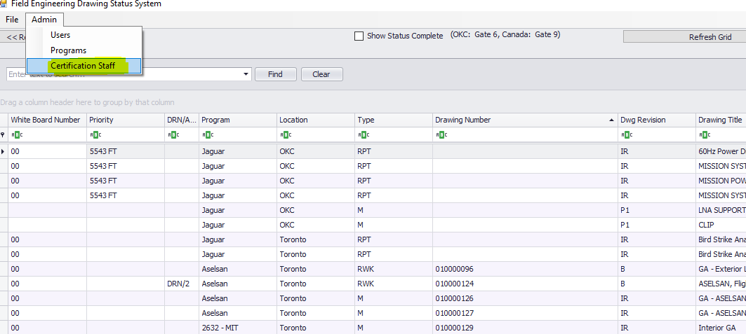  
  
After you click on the Certification Staff menu item highlighted above, you will see the following screen.  
  
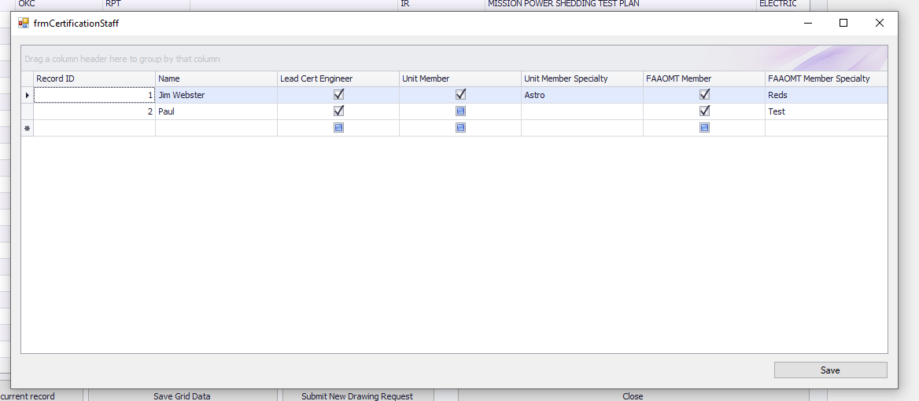

**B. Program Management (Defining Programs, Setting Up Certification Preferences by Program)**  
  
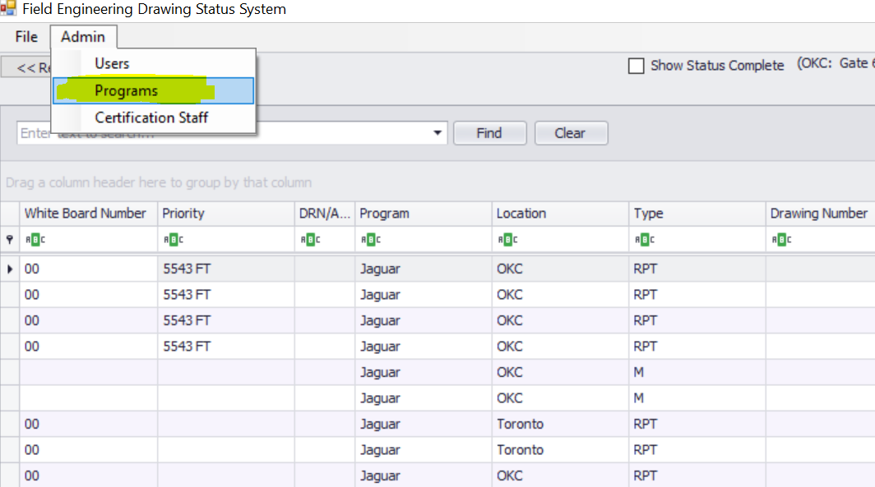  
  
After you click on the Programs menu item highlighted above, you will see the following screen.  
  
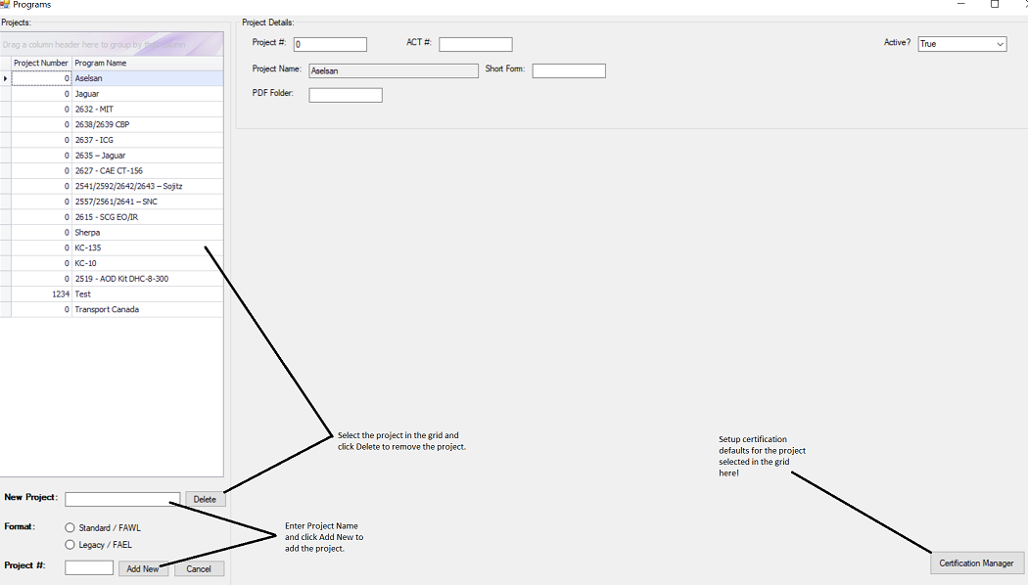  
  
To setup the certification defaults for a program, click on the button pictured above labeled Certification Manager. When you click on this button, you will be taken to the following screen.  
  
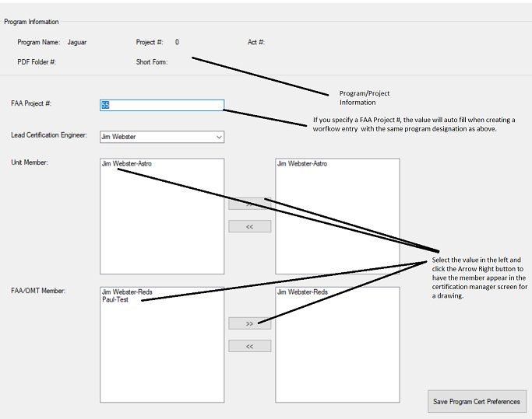  
  
  
  
  
  
  
  
  
  
  
  
  
  
  
  
  
C. Certification Screen (Document Level)  
  
To access the certification screen for a drawing, click the highlighted button. (See below example)  
  
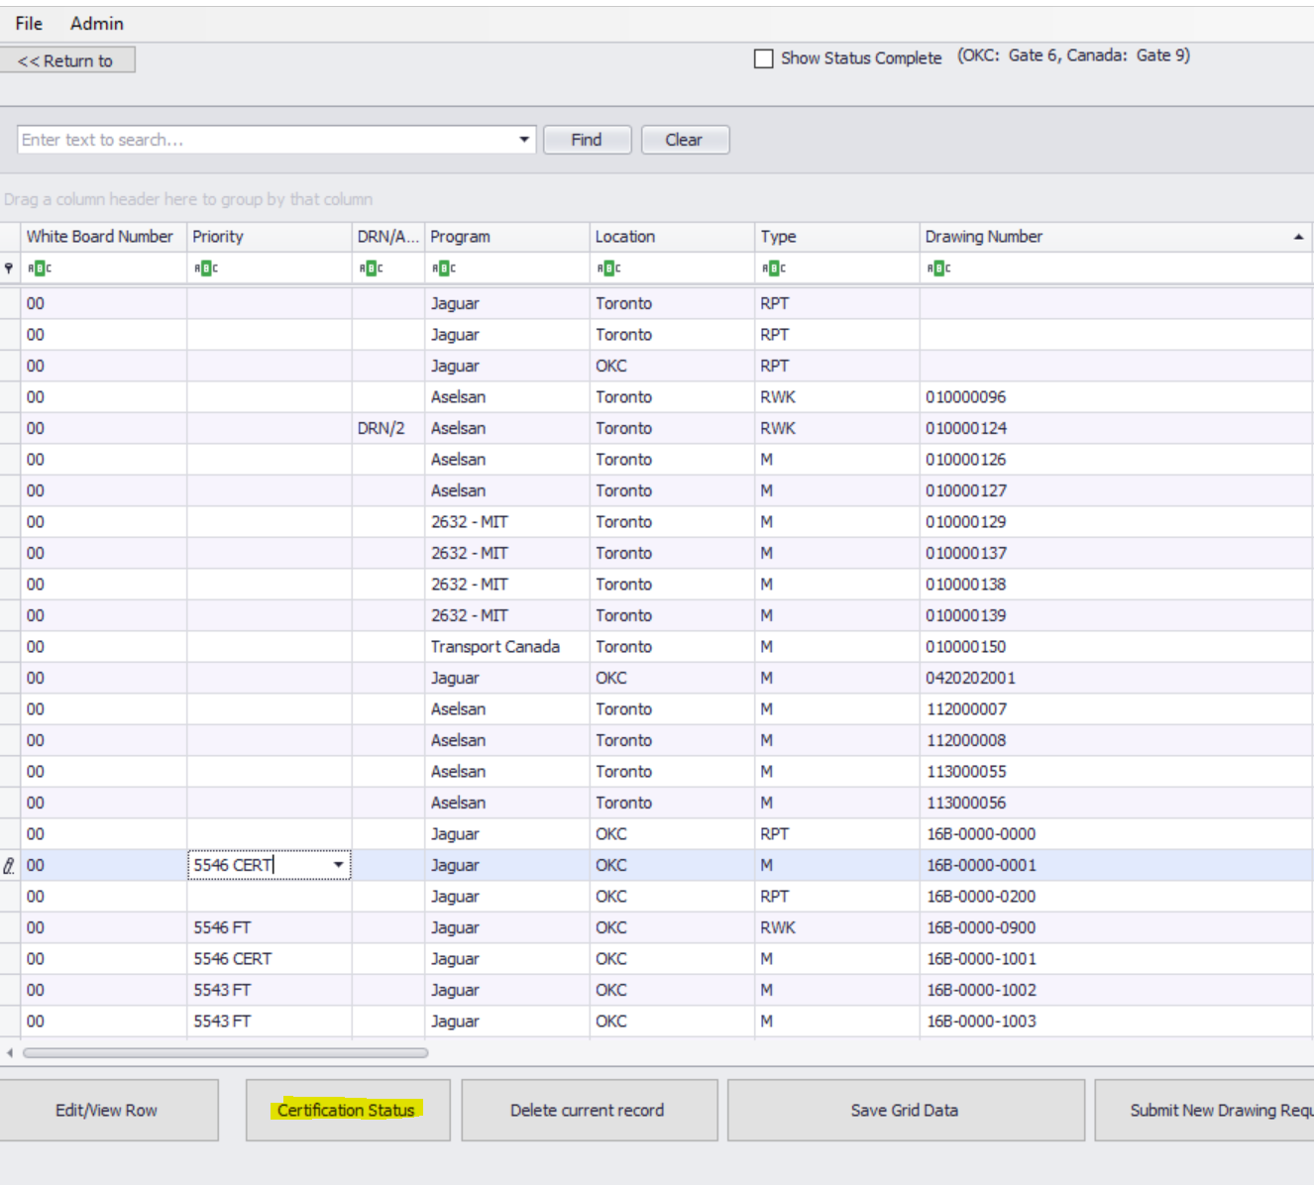  
  
After clicking on certification status, you will see the following screen.  
  
